Prayer for Missions
Every other Sunday, 3:00-4:30 pm at home in West Cobb
Andrea Schmidt: japandreas01@gmail.com
Do you have friends or relatives who are missionaries? Do you have a heart for the lost around the world? Do you want to stay connected to what God is doing in the world? This small group will be dedicated to praying for our missionaries and the populations they serve. We pray for specific requests of StoneBridge missionaries and the countries they live in. We also try to have missionaries visit our group to share with us what the Lord is doing in their country and let us know how we can pray for them! We would also love to pray for the requests of any missionaries you know. Anyone is welcome!
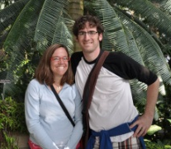 | Dead to be Read *Childcare Available  Mondays, 6:30 pm at StoneBridge 164  Maggie & Alan Bowling: magbowling@gmail.com  Study a Christian Classic with Alan and Maggie Bowling. Learn from the Saints who have stood the test of time.
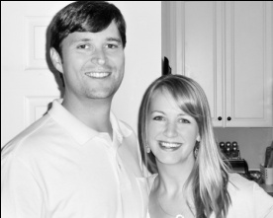 | Connect *Childcare Available  Fridays, 6:30-8:45pm in 164  Brent and Ann Purcell: brent.purcell@gmail.com, anncpurcell@hotmail.com  CONNECT Small Group is OPEN TO ANYONE! Our goal is to connect with God and each other in a deeper way. We enjoy a pot-luck dinner, we will discuss the sermon from Sunday, and spend time in prayer & personal ministry each week. We occasionally watch a short video or worship together. We also look for outreach opportunities in our community.
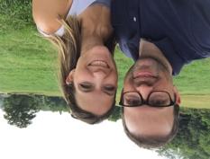 | Seth and Tracy Lytle: stlytle@gmail.com *Childcare Available  Wednesdays from 7:00-8:15 at home in Kennesaw  Our small group will meet weekly and simply focus on the message from the previous Sunday at Stonebridge. No special rotations or break outs, we're just looking to build and strengthen relationships within the church through group discussion around that week's message.
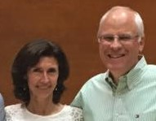 | Marriage and Parental Discipleship  Scott and Tina Williford: thewillifords@hotmail.com *Childcare Available  Monday nights from 6:30 to 8:00 at StoneBridge  Each week will discuss the sermon from the previous Sunday and focus on applying those truths to our marriages and how they apply as parents. This group is open to anyone but we would really love to see married couples with or without children.
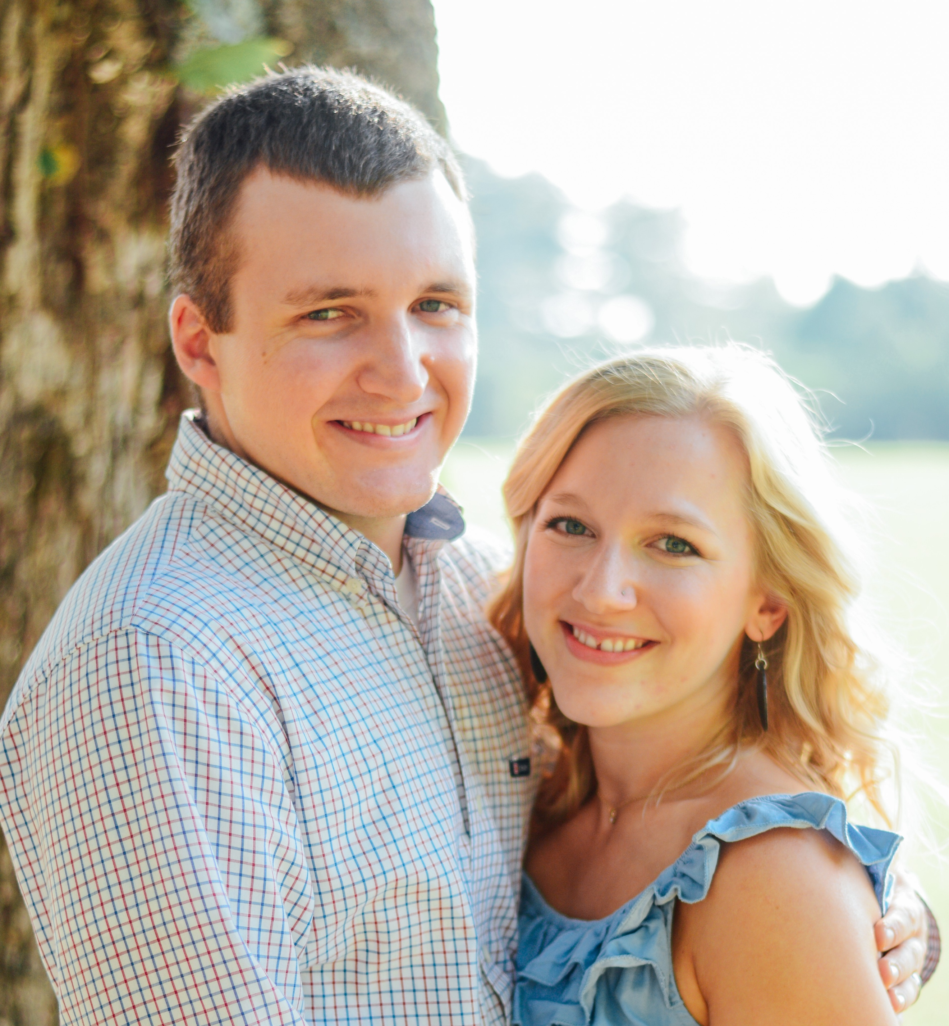 | 20 Somethings (or 30s) * No Childcare  Brad and Sierra Waller:  bwaller5@bellsouth.net sierawaller5@gmail.com Friday nights 7 pm at our home  We plan to talk about study the scriptures verses from the previous week’s sermon, eat yummy dessert and have community building nights where we play games or have bon fires. If you are in the 20 something demographic married or single, we would love to have you join us.
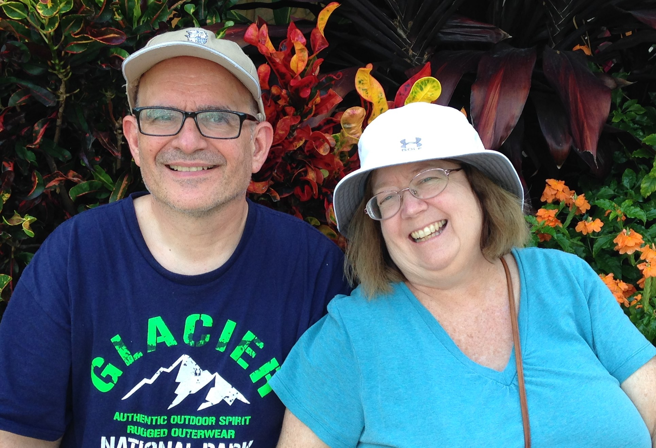 | 1 John Bible Study *No Childcare  Richard and Becky Bly: farm_eieio@yahool.com, beckybly1964@yahoo.com  Thursdays 7-9  We will be doing a Bible Study on the book of 1 John beginning Thursday night January 26th from 7-9. We will meet at a home in East Cobb. Home work is optional. No childcare.
Brian and Ericka Fulghum *Childcare Available
Dreams – Tuesday nights in 164 6:30-8pm Erickafulghum@gmail.com
Reading through life of Daniel who moved in dreams and visions. Will gather for time of fellowship, and discuss practical advice for discerning and stewarding God’s voice. (Key verse: Dan. 5:12.) 3 weeks on discernment, interpretation and symbolism; 3 weeks on how-to deal with intercessions warnings, and evil; 1 week on application. For anyone who is curious, wanting to better steward revelation and dreams, or experiencing revelatory gifts and wanting to connect.
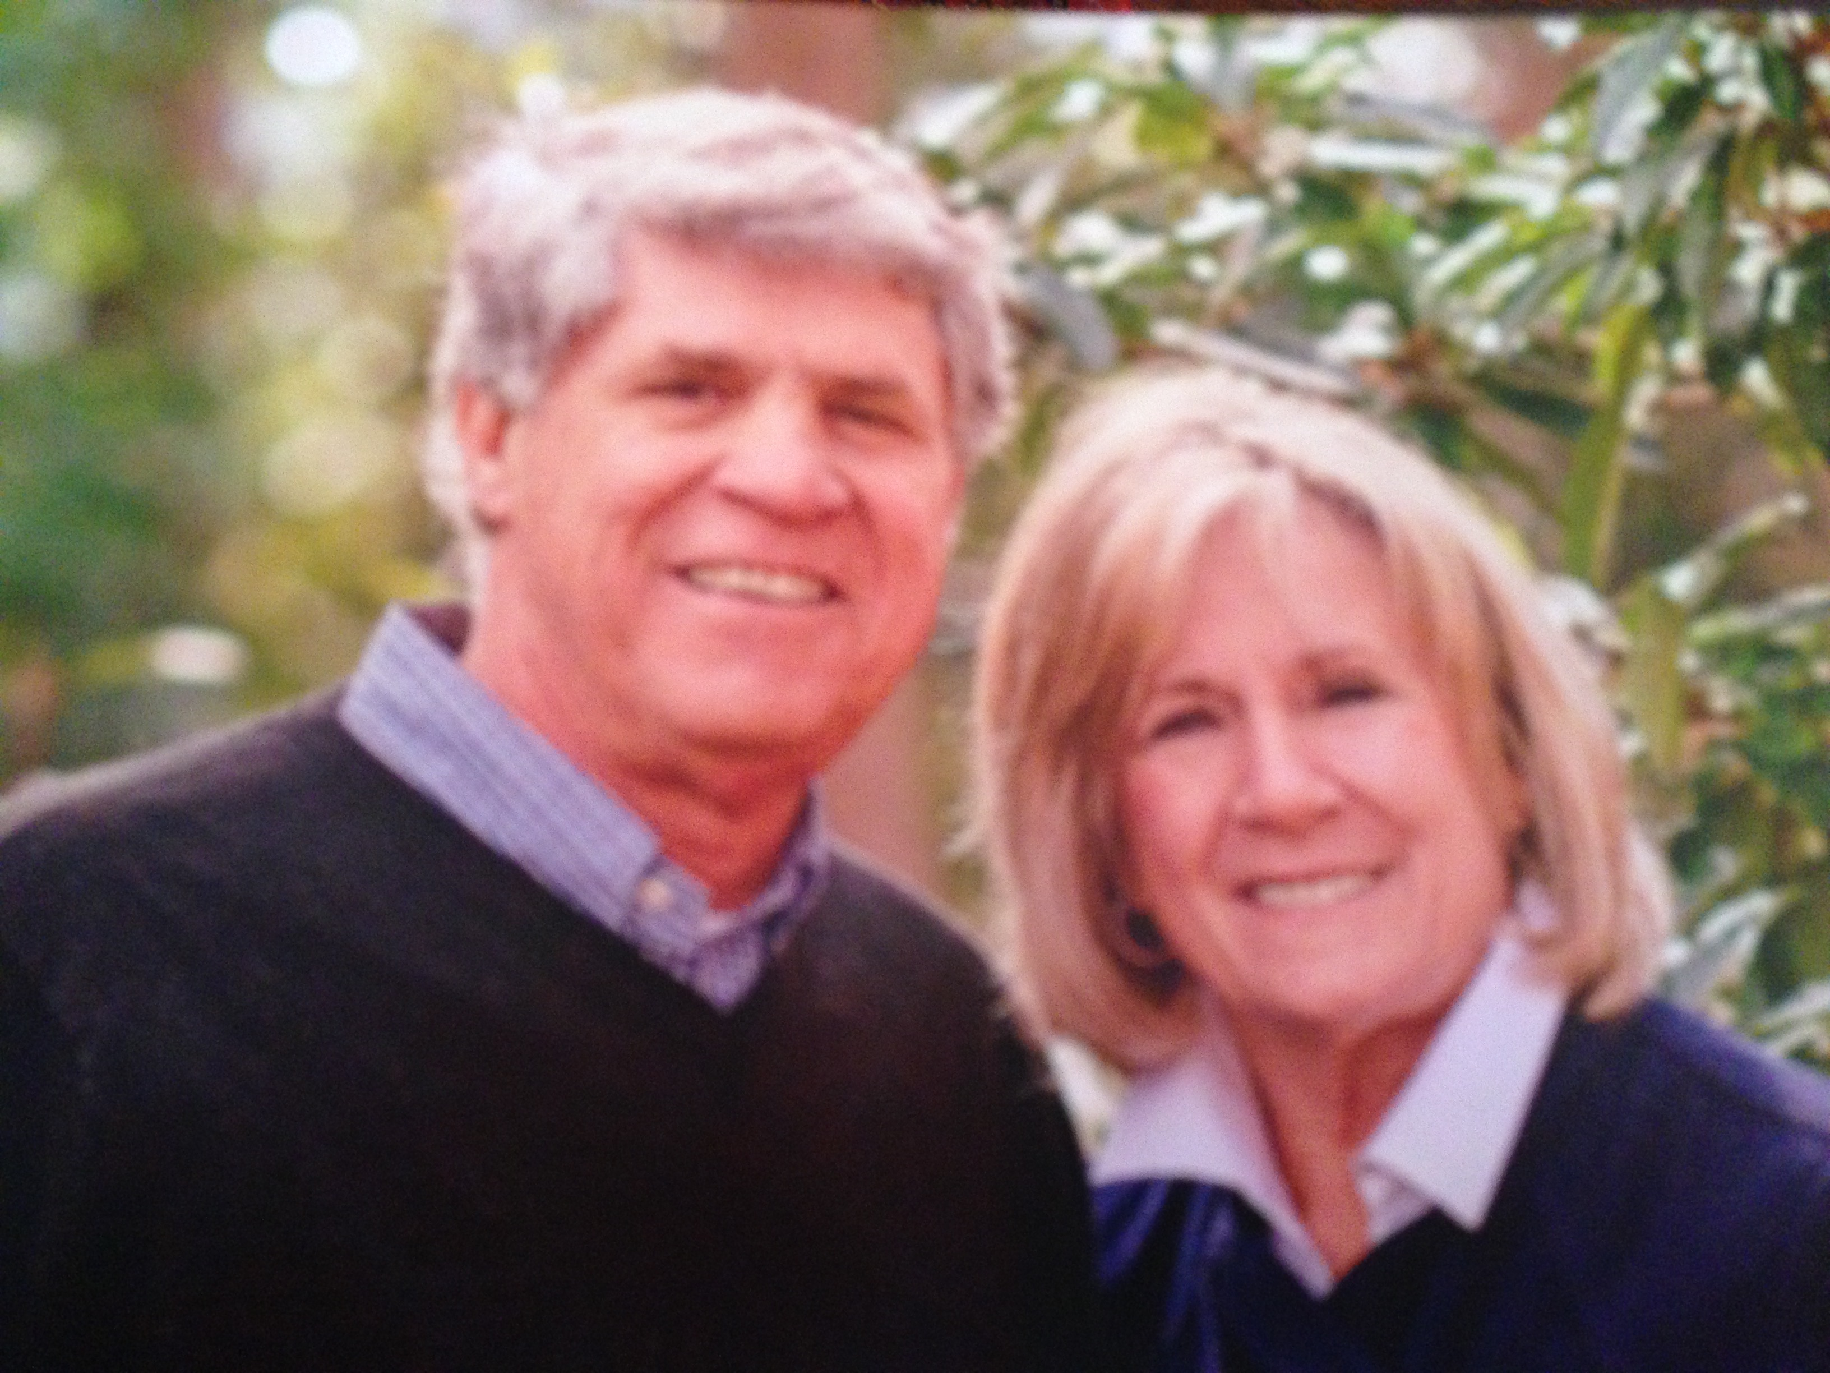 | Young Married Couples *Childcare available  Reed and Betty Konigsmark: wrk2@att.net  Sunday afternoons 3:30-5:00  This group would meet before the 5:00 service and then attend church. Our goal is that young married couples would address spiritual gifts (knowing your spouse's gift in particular, same for personality, 5 love languages), then communication, handling money, children, in-laws, sex, etc.

Women’s groups
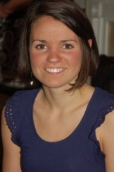 | Mom-to-Mom *Childcare Available  Wednesdays, 9:30am-11:30am in 164 Ruth Allen Bryant: Ruthallenbryant@gmail.com  Mom to mom is a Bible study for moms of young children. We visit, study the bible, laugh, pray and encourage each other. We always welcome new moms who are looking for friends and community.
Following Jesus Together
Thursdays, 6:30pm in 164
Melissa Wilkins: melissamwilkins@aol.com
We will be studying 1 Peter and specifically applying the truths of Bible study into our lives. Our first meeting will be January 26 in 164.
Men’s Groups
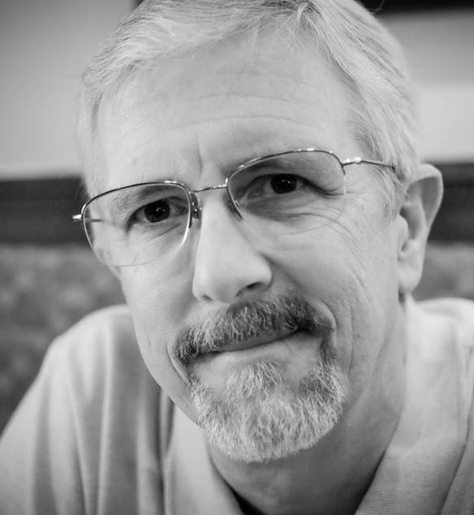 | Better Life  Mark Kelly: Markalankelly@gmail.com 404.580.9526  Thursdays 7:00 pm at 164  Men wrestle with many frustrations and problems. Sometimes things just make no sense. We know the life we are experiencing can't be what God had in mind for us — and that there's got to be something more. This is a group of men who want to take hold of life the way God designed it to be lived.
Not quite small groups
Forrest Shealy: Church History
Forrestshealy@gmail.com
Getting ready for a seven week survey of Church history. Dry stuff, ehh? But not if you see it for what it is: real people living out their faith and sometimes some horrible institutional messes. Did you know the church prospered in the Sassanian Persian Empire and what is now Iran and Iraq? Did you know the church spread through India in the 2d century and spread into Asia, the steppes of southwest Asia and into China? Did you know the church has roots in Africa as old as the saints themselves and Carthage, Alexandria and much of present Egypt were home to great leaders and populations of the early church? Have you heard of the Nubian kingdoms and that Christianity led in what is now the Sudan well into the 14th century and still has roots there? Did you know that much and most of the church is culturally distinct from what you may remember and still experience on Sunday morning?
I have had the opportunity to learn some of this and look forward to learning more as I learn more and more of the beauty of God and his creation and his desire to restore his creation and his people.
Foundations *Childcare Available
Jeremy Morris: Jeremy@StoneBridgemarietta .org
Sunday Afternoons 2:00- 3:30 Beginning January 29th (6 weeks) in 164
The purpose of this group is to create an on ramp for people looking for community as well as dig deeper into the foundations of StoneBridge Church. If you are new to StoneBridge this is a great way to connect to your new church family.
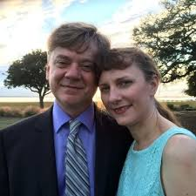 | Leaders: Bryan and Susan Coley  Mondays, 6:30-8:30, REEL Studios, 188 Anderson Street.  Begins 2/6. For more info, or to tell us you'll attend: please email suzyhomeschooler@icloud.com.  #Listening  This small group is for those whose hearts grieve over the racial divide in our churches and our country. We will gather to pray, learn, and most importantly listen, to voices from the African-American community, and potentially other people of color. The long-term goal is to intentionally develop relationships with believers in racially-diverse area churches and begin small groups through bethebridge.org.

